Sensitivity to copper exposure and the effects of genetic diversity on population dynamics in Daphnia pulex and Daphnia pulicaria

Piumi Abeynayaka
Department of Biology

McGill University
Montreal, Quebec

May 2016

Table of Contents
Abstract i
Introduction 1
Methods and Materials 2
Toxicity tests 2
Table 1: Habitats used in microcosm experiment 4
Table 2: Clones used in toxicity assay and microcosm experiment. Clonal lines highlighted in grey were assessed in the toxicity assay. Mono=monoculture; low=low diversity; high=high diversity. 4
Experimental design of microcosm experiment 5
Levels of diversity 5
Choosing genotypes 6
Figure 1: Experimental design of microcosm experiment 7
Daphnia culturing and tank setup 8
Experimental Daphnia maintenance and sampling 8
Analysis 9
Toxicity test 9
Microcosm population size analysis 10
Table 3: Calculated LC₁₀ and LC₅₀ values, sorted by smallest difference 11
Table 4: Tank population size data, including CV and r calculations 12
Results 12
Toxicity test 12
Figure 2: Copper LC₁₀s and LC₅₀s of lines tested in toxicity assays 14
Effect of diversity treatments on population growth rate and size 14
Table 5: Results of linear mixed effects models 14
Figure 3: Population size estimates over time for monoculture, low diversity, and high diversity tanks. Matching colours indicate tank pairs within each diversity treatment. 15
Discussion 16
Conclusion 20

Abstract
Metal contamination is known to have a negative impact on aquatic communities and their levels of genetic diversity. For this reason, it is vital to develop an understanding of the sensitivities to various metal compounds exhibited by basal aquatic invertebrates, such as Daphnia. D. pulex and pulicaria remain understudied relative to D. magna, which is a less ecologically representative model species. Therefore, we employed 48-hr toxicity assays to assess how these two species vary geographically as well as inter-clonally in their tolerance to copper contamination. Given the known role of metal contamination in eroding genetic diversity in natural populations, we also ran a month long microcosm experiment to investigate how differing levels of intra-specific diversity may impact Daphnia population dynamics. We found statistically significant differences between D. pulex (pond) and pulicaria (lake) clonal lines in their LC₅₀ copper tolerance levels (p = 0.003), but no overall geographic differences were found. In general, clonal lines did not exhibit much variation in their responses to copper and were all quite likely to experience significant mortality within a very narrow range of copper concentration. Finally, in contradiction to other studies, our microcosm experiment suggested that increasing levels of genetic diversity reduced population stability (as measured by a coefficient of variation) (p = 0.0471) and also had no effect on population growth rates. We conclude by offering suggestions for methodological improvements to the experiments performed herein.

Introduction
Freshwater ecosystems are amongst the most threatened habitats on the planet . They also happen to be among the most valuable ecosystems, as measured in terms of the ecosystem services they provide (per hectare) . Conservation of these environments requires a detailed understanding of how aquatic organisms and communities respond to various stressors. One particularly deleterious anthropogenic stressor in freshwater systems is heavy metal pollution, which is typically a by-product of mining operations. Daphnia are valuable model organisms for studying the ecological consequences of metal contamination; not only are they sensitive to heavy metals , but they also play a role as keystone species in many freshwater communities .
Most of the studies in this field make use of D. magna as the primary test organism for toxicity assays. However, several authors have questioned whether this species can truly serve as a representative model organism . In particular, certain studies suggest that pond invertebrates such as D. magna exhibit lower sensitivity to copper than do lake invertebrates , thereby bringing into question whether the results of toxicity assays performed on D. magna are generalizable to broader aquatic invertebrate communities. Furthermore, many studies also restrict their assays to just a handful of clonal lines per species, which runs the risk of overlooking inter-clonal variation in metal sensitivity .
We contend that D. pulex and D. pulicaria (both of which are members of the D. pulex complex) serve as superior model organisms as they have a broad geographic range and also have substantial genomic resources available . Therefore, in the first part of the present study, we seek to characterize the inter-clonal variation and geographic variability in copper sensitivity exhibited within this species complex. Additionally, as D. pulex is largely restricted in range to pond habitats and D. pulicaria to lakes , we also seek to further characterize whether differences in copper sensitivity between these two habitat types may also be present.
In addition, a particular concern associated with metal contamination is the potential impact it can have on genetic diversity (through mutagenic effects or genotoxicity) . The genetic erosion hypothesis suggests that exposure to metals can contribute to a decline in population genetic diversity , and this has been found to be the case in natural Daphnia populations . This is a cause for concern as recent research shows that intra-specific diversity, much like species-level diversity , also has ecological significance at the population, community, and ecosystem levels . Thus, in the second part of this study, we seek to elucidate how differing levels of intra-specific diversity may influence Daphnia population dynamics within a tank-based microcosm experiment.
Methods and Materials
Toxicity tests
In order to determine the range of copper tolerances demonstrated by the various Daphnia genotypes, a 48-hr toxicity assay was performed on randomly selected clonal lines from each of 12 habitats represented in the clone library (Table 1 and ). Ten mothers for pond Daphnia and twenty mothers for lake Daphnia were randomly selected from beakers in the clone library for each clonal line and were then cultured in 30 ml of FLAMES medium inside Drosophila vials. They were fed 0.5 ml of a 1:1:1 mixture of Ankistrodesmus, Scenedesmus, and Pseudokirchneriella algae twice per week. The vials were checked for broods every second day so as to ensure that neonates used in the assays were no older than 48 hours. On days where insufficient numbers of neonates had been produced for a toxicity assay to be performed on a given clonal line, the mothers were transferred into fresh medium and fed while the neonates were discarded.
To prepare the copper solutions, a primary 10,000 µg Cu/L dilution in FLAMES medium was prepared from a stock 10,000 µg Cu/ml stock solution. This dilution was allowed to sit for 24 hours in order to redox fully and was then used to prepare 4L solutions at target concentrations of 150, 156, 162, 168, 174, 180, and 186 µg/L. However, the concentrations of the final solutions were found to be diluted below the target levels, so their actual concentrations were later measured using inductively coupled plasma mass spectrometry (ICP-MS): 143.95, 148.30, 153.35, 156.20, 158.45, 160.35, and 165.50 µg/L. These solutions were also allowed to sit for a day before being used in any bioassays.
A single large batch of FLAMES medium was prepared initially and used in the preparation of each dilution (including the primary dilution). Four litres of this batch of copper-free FLAMES was isolated and stored in the same manner as the other solutions and was later used as the control solution in the toxicity assays. All the assays were used within two weeks of the solutions being prepared.
Only third brood neonates were used in the assays. Each neonate was transferred into a 25 ml vial of the copper solution so as to prevent algal transfer before being transferred into the final 30 ml vial. Five neonates were placed in each concentration of the gradient. The vials were then sealed with parafilm and arranged randomly in a 100-cell tray which was placed in a growth chamber for 48 hours. Mortality was confirmed by eye – neonates were considered dead if no movement or heartbeat could be seen. Owing to limitations in the volume of copper solutions available, not every clonal line was tested against the full range of concentrations but they were all tested against at least 3 concentrations. Additionally, we attempted to set up two replicates per clonal line but were unable to do so for certain genotypes ().

Table 1: Habitats used in microcosm experiment
Code | Location name | Type | Location | Latitude | Longitude | State
BN | Bridge North | Pond | Kickapoo State Park | 40.1221 | -87.7367 | Illinois
C | Center | Pond | Trelease Woods | 40.13291 | -88.14004 | Illinois
CL | Clear | Lake | Kickapoo State Park | 40.1419 | -87.7378 | Illinois
DL | Deep | Lake | Kickapoo State Park | 40.13254 | -87.73641 | Illinois
DISP | Disputed | Pond |  | 42.17 | -83.03 | Ontario
DP | Dump | Pond |  | 40.2428 | -87.7795 | Illinois
GN | Glen | Lake | Muskoka | 45.08 | -78.3 | Ontario
LL | Long | Lake | Kickapoo State Park | 40.13254 | -87.73641 | Illinois
SOLO | Solomon | Pond |  | 42.71 | -85.38 | Michigan
SL | Sportsman's | Lake | Kickapoo State Park | 40.14 | -87.44 | Illinois
STM | St. Michael | Pond |  | 42.23 | -83.07 | Ontario
T | Top | Pond |  | 40.242 | -87.7824 | Illinois

Table 2: Clones used in toxicity assay and microcosm experiment. Clonal lines highlighted in grey were assessed in the toxicity assay. Mono=monoculture; low=low diversity; high=high diversity.
Habitat | Clone # | Type | Tank | Treatment | # of toxicity assay replicates
DL | 24 | Lake | 1 | mono | 2
SL | 19 | Lake | 2 | mono | 3
BN | 29 | Pond | 3 | mono | 2
C | 10 | Pond | 4 | low | 2
LL | 5 | Lake | 4 | low
SL | 25 | Lake | 4 | low
C | 6 | Pond | 5 | low
DL | 29 | Lake | 5 | low | 2
T | 10 | Pond | 5 | low | 3
CL | 21 | Lake | 6 | low
LL | 1 | Lake | 6 | low | 2
T | 16 | Pond | 6 | low
BN | 14 | Pond | 7 | high
C | 18 | Pond | 7 | high
CL | 6 | Lake | 7 | high
CL | 20 | Lake | 7 | high | 2
DISP | 9 | Pond | 7 | high
DISP | 18 | Pond | 7 | high
DISP | 40 | Pond | 7 | high | 2
GN | 11 | Lake | 7 | high | 1
GN | 12 | Lake | 7 | high | 1
GN | 36 | Lake | 7 | high
T | 6 | Pond | 7 | high
T | 15 | Pond | 7 | high | 2
BN | 2 | Pond | 8 | high | 2
BN | 10 | Pond | 8 | high
BN | 26 | Pond | 8 | high
C | 17 | Pond | 8 | high
CL | 29 | Lake | 8 | high | 2
DISP | 14 | Pond | 8 | high
DL | 5 | Lake | 8 | high
DL | 22 | Lake | 8 | high
DP | 3 | Pond | 8 | high | 2
GN | 38 | Lake | 8 | high
LL | 10 | Lake | 8 | high
LL | 15 | Lake | 8 | high | 3
BN | 21 | Pond | 9 | high
C | 11 | Pond | 9 | high | 2
CL | 28 | Lake | 9 | high
DISP | 15 | Pond | 9 | high
DP | 4 | Pond | 9 | high | 2
DP | 9 | Pond | 9 | high
DP | 20 | Pond | 9 | high
DP | 25 | Pond | 9 | high
LL | 12 | Lake | 9 | high
SL | 8 | Lake | 9 | high
SL | 18 | Lake | 9 | high
SL | 23 | Lake | 9 | high
SOLO | 7 | Pond | None | None | 2
STM | 3 | Pond | None | None | 2
STM | 4 | Pond | None | None | 1

Experimental design of microcosm experiment
Levels of diversity
Three sets of diversity treatments were created: zero diversity, low diversity, and high diversity. Each treatment had 3 replicate pairs consisting of equal levels of genotypic richness but with different combinations of genotypes (for a total of 6 tanks per treatment). Each replicate pair had identical genotypic combinations.
Each higher level of diversity subsumed the genotypic combinations of the level beneath it. The zero diversity tanks consisted of three monocultures of three different clonal lines (with replicate pairs of each line). The low diversity treatments had 6 genotypes per tank: three of which were the same as those used in the monocultures while three were unique genotypes. As such, there were three genotypes common to all three tanks and three unique to each one, leading to a total of 12 genotypes used in the entire treatment. Similarly, the high diversity treatments had 24 genotypes per tank, with 12 being identical to those used in the low diversity treatment plus 12 unique types – for a total of 48 types in the entire treatment (Figure 1).
Choosing genotypes
The clone library contains Daphnia sourced from 16 different locations, 9 of which were ponds and 7 were lakes, from Illinois, Michigan, Minnesota, and Ontario. Three habitats were excluded from the experiment as Daphnia from those locations were hatched from ephippia collected from sediment. Two further habitats were excluded owing to a paucity of genotypes from those locations available in the collection and a final habitat from Ontario was excluded so as to minimize the level of spatial variation represented in the range of genotypes used in the experiment . Thus, the final configuration consisted of eight habitats from Illinois and two from Michigan (Table 1).
A grand total of 48 clonal lines were chosen from these ten habitats: eight of the habitats contributed five lines each and the remaining two habitats contributed four lines each. Whether a given habitat contributed 4 or 5 lines was determined at random. Any lines from those habitats that had been tested in the toxicity assay were included. The remaining 27 lines were selected at random from the remainder of the clone library.
When assigning the lines to different treatments, the 3 monocultures were the first to be selected. These were the only lines that were assigned non-randomly: first, three habitats were chosen at random out of the ten available ones, and then for each of the habitats, one out of the two genotypes that had been used in the toxicity assay for that particular habitat was selected. This was done so as to ensure that data about the copper tolerances of these lines would be available for comparison against the results of the microcosm experiment and to ensure that each monoculture replicate pair represented a different habitat. Subsequently out of the remaining bank of 45 clonal lines selected for use, nine were assigned at random to the low diversity treatment. Then those nine lines were again assigned at random to one of the three replicate pairs. Finally, the remaining 36 lines were distributed randomly between the three high diversity replicate pairs ( and Figure 1).
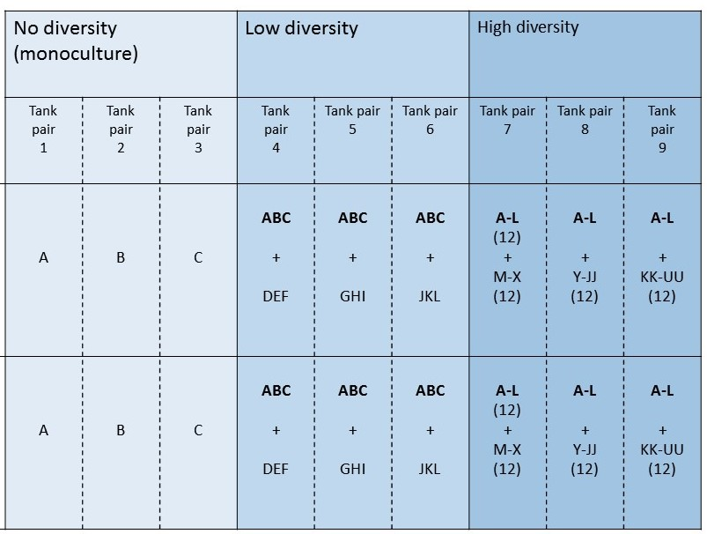

Figure 1: Experimental design of microcosm experiment

Daphnia culturing and tank setup
Female adult Daphnia were selected from a clone library (for details see Choosing genotypes above) and allowed to reproduce in drosophila vials with FLAMES medium , while being fed 0.5 ml of a 1:1:1 mixture of Ankistrodesmus, Scenedesmus, and Pseudokirchneriella algae twice per week. The produced offspring were then transferred to additional vials and thus allowed to increase exponentially. Once a sufficient number of neonates were obtained, individual neonates were isolated into separate vials at least 48 hours prior to seeding the tanks and within 2 days of their hatching. This was done in an effort to ensure that neonates of different clonal lines were reared in environments that were as similar as possible to each other and, also, in order to prevent ephippia production as a consequence of overcrowding. The cultures were maintained in the same chamber where the tanks were later set up to ensure that the neonates would have time to acclimate to the environment (see Experimental Daphnia maintenance and sampling).
The Daphnia were seeded at a density of 48 individuals per tank into 9L of FLAMES medium. Most neonates were between 3 to 7 days old (roughly juvenile stage). The tanks in question were circular HDPE containers with a 12L volume. They were filled with FLAMES over the course of two weeks in 4 batches: 4 2L batches and 1 1L batch. All tanks received equal amounts of each batch to ensure homogeneous environments between tanks. The tanks were also weighed while empty so that later the volume of medium contained in the tanks could be estimated via weighing,
Experimental Daphnia maintenance and sampling
The tanks were kept in a walk-in chamber that was maintained at a 12-hour photoperiod and with a temperature between 17-20°C. They were fed biweekly with 1.5 ml of a 10× concentrated algae mixture of 3 species (Ankistrodesmus, Scenedesmus, Pseudokirchneriella).
The population size of each tank was estimated on 4 separate occasions (between March 21st, 2014 and April 17th, 2014) via sampling with 25ml scintillation vials. The sampling protocol comprised four samples from each quadrant of the tank and four from the center (half in the upper layer of the tank and half near the bottom), for a total of 20 samples per tank (with replacement and stirring of the tank after every second sample).
The protocol was verified prior to commencing the experiment by sampling a test tank that was incrementally seeded with known quantities of miscellaneous Daphnia. The test served to establish that the protocol is reasonably accurate at inferring large population sizes but loses accuracy at smaller population levels. Importantly for the purposes of this experiment, the protocol was reliable for establishing relative population size (as opposed to absolute population size) (data not shown).
Before and after sampling, tanks were weighed with a 12kg ± 1g balance so as to track evaporative loss of medium between sampling events as well as loss of FLAMES medium owing to sampling.
Analysis
Toxicity test
Mortality percentages were averaged between replicates (when more than one replicate was available for a given line) and analyzed in R version 3.2.3 with the dose.p function contained in the “MASS” package . The log values of the copper solution concentrations were taken (in order to compensate for overdispersion) and modelled against the average percent mortality of each clonal line with a probit regression model. The dose.p function was then used to calculate the LC₁₀ and LC₅₀ of each clonal line (Table 3). These data were grouped according to whether the lines originated from lakes or ponds and then were assessed with the Levene’s test function in the “car” package for equality of variance. The variances were found to be homogeneous for both LC₅₀s and LC₁₀s (Levene’s test: F = 0.90, p = 0.35 and F = 1.44, p = 0.24 respectively). However, the LC₅₀ values of the pond group were non-normal (Shapiro-Wilk test: W = 0.63, p < 0.001). Log and square root transformations were unsuccessful at imposing normality. Therefore, a non-parametric Wilcoxon signed-rank test was applied to analyze differences in LC₅₀ and a two sample t-test was used to examine LC₁₀ differences. Finally, two one-way ANOVAs were performed to assess whether individual habitats also exhibited differences in their copper tolerance levels. As the data per habitat were very heteroscedastic (Levene’s test: F > 10²⁶, p < 0.001 for both tests), a Welch’s correction was again applied. Data from Disputed pond, Solomon pond, and Sportman’s lake were excluded as they only had one replicate clonal line each, resulting in zero variance. Subsequent to the ANOVAs, pairwise Welch’s t-tests with a Bonferroni correction were performed to identify particular habitats with differing copper tolerance levels.
Microcosm population size analysis
Sample counts of the tanks’ population sizes were multiplied by 18 to approximate the total population size in the tanks because the total volume of samples taken per tank (500 mL) was approximately 1/18th of the total volume of a tank. Two summary measures of the population size time-series were taken: the coefficient of variation, CV, and the exponential growth rate, r. The former measure expresses the overall variability of a given tank’s population size through time relative to the mean population size. The latter was calculated according to the exponential growth equation for the period between the initial seeding event (when P = 48) and the maximum observed population size for each tank ().
Subsequently, the effects of genetic diversity on CV and r were examined using a linear mixed effects model. Genetic diversity was modelled as a fixed effect, and the tank pairs were treated as a random effect nested within the diversity treatments. The model was then used to perform two-way ANOVAs for the two dependent variables (CV and r). Significant ANOVA results were subsequently analyzed with a post-hoc Tukey test using the “TukeyC” package in R . Residuals of the models were visually inspected to confirm that the assumptions of normality and homoscedasticity were met.

Table 3: Calculated LC₁₀ and LC₅₀ values, sorted by smallest difference
Type | Clone | LC₁₀ | Log(LC₁₀ SE) | LC₅₀ | Log(LC₅₀ SE) | Difference between LC₅₀ and LC₁₀
Pond | STM.4 | 157.1057 | 4.018981 | 157.3142 | 4.156712 | 0.208555
Lake | GN.12 | 158.1818 | 1.672384 | 158.5162 | 0.412071 | 0.334371
Pond | STM.3 | 157.7408 | 2.880883 | 158.095 | 1.440442 | 0.354199
Lake | CL.29 | 157.839 | 3.884545 | 158.2075 | 1.539826 | 0.368532
Pond | DP.4 | 157.919 | 2.833558 | 158.2956 | 0.82279 | 0.376616
Lake | DL.24 | 157.6076 | 0.001261 | 159.2161 | 0.000761 | 1.608418
Pond | DISP.40 | 156.5035 | 0.001251 | 158.1192 | 0.000775 | 1.615664
Pond | T.15 | 155.8071 | 0.001426 | 157.6881 | 0.000856 | 1.881074
Pond | C.10 | 156.1342 | 0.00148 | 158.1623 | 0.00088 | 2.028134
Lake | LL.1 | 156.6078 | 0.001627 | 159.0092 | 0.00101 | 2.401382
Lake | SL.19 | 157.1201 | 0.001639 | 159.5353 | 0.001102 | 2.415239
Lake | LL.15 | 156.5693 | 0.001686 | 159.0508 | 0.001048 | 2.481556
Lake | DL.29 | 156.7912 | 0.001705 | 159.3323 | 0.001112 | 2.541039
Pond | C.11 | 154.0542 | 0.001914 | 156.8002 | 0.001101 | 2.746015
Pond | T.10 | 155.5204 | 0.002082 | 158.7992 | 0.001296 | 3.278768
Pond | BN.29 | 154.1861 | 0.002347 | 158.0949 | 0.001373 | 3.908858
Lake | GN.11 | 155.7667 | 0.002152 | 159.77 | 0.001485 | 4.003237
Lake | CL.20 | 154.4053 | 0.002533 | 158.8329 | 0.001523 | 4.427567
Pond | BN.2 | 153.9949 | 0.002765 | 158.7712 | 0.001604 | 4.776304
Pond | SOLO.7 | 150.7873 | 0.004944 | 157.4708 | 0.002123 | 6.683483
Pond | DP.3 | 156.2601 | 0.003456 | 164.1389 | 0.003646 | 7.878787

Table 4: Tank population size data, including CV and r calculations
Tank | Copper | Diversity | Population size estimates |  |  |  |  | Mean | CV | r
Tank | Copper | Diversity | 2014.03.12 | 2014.03.19 | 2014.03.26 | 2014.04.01 | 2014.04.17 | Mean | CV | r
1 | no | mono | 48 | 36 | 252 | 432 | 648 | 283.2 | 0.921841 | 0.072297
2 | no | mono | 48 | 90 | 234 | 342 | 756 | 294 | 0.964272 | 0.076579
3 | no | mono | 48 | 108 | 1512 | 1296 | 360 | 664.8 | 1.036579 | 0.246428
4 | no | low | 48 | 0 | 234 | 990 | 684 | 391.2 | 1.099352 | 0.151325
5 | no | low | 48 | 90 | 720 | 1764 | 504 | 625.2 | 1.113955 | 0.180207
6 | no | low | 48 | 18 | 342 | 1242 | 810 | 492 | 1.069701 | 0.162664
7 | no | high | 48 | 18 | 414 | 1242 | 522 | 448.8 | 1.10399 | 0.162664
8 | no | high | 48 | 36 | 774 | 1710 | 504 | 614.4 | 1.119786 | 0.178652
9 | no | high | 48 | 18 | 558 | 1602 | 648 | 574.8 | 1.116798 | 0.17539
10 | yes | mono | 48 | 18 | 234 | 864 | 1332 | 499.2 | 1.156016 | 0.092312
11 | yes | mono | 48 | 18 | 198 | 486 | 1008 | 351.6 | 1.169197 | 0.08457
12 | yes | mono | 48 | 90 | 1530 | 1116 | 594 | 675.6 | 0.955659 | 0.247273
13 | yes | low | 48 | 54 | 558 | 1404 | 486 | 510 | 1.084429 | 0.168794
14 | yes | low | 48 | 72 | 540 | 1836 | 702 | 639.6 | 1.137516 | 0.182207
15 | yes | low | 48 | 36 | 522 | 1296 | 648 | 510 | 1.016541 | 0.164792
16 | yes | high | 48 | 18 | 288 | 1170 | 558 | 416.4 | 1.138447 | 0.159678
17 | yes | high | 48 | 36 | 846 | 1998 | 720 | 729.6 | 1.098233 | 0.186435
18 | yes | high | 48 | 0 | 486 | 1656 | 810 | 600 | 1.129447 | 0.177048

Results
Toxicity test
The mean LC₅₀ across all lines was 158.42 µg/L and the standard deviation was 1.45 µg/L. In comparison, LC₁₀ values were more variable with a mean of 156.04 µg/L and standard deviation of 1.77 µg/L (Figure 2). The range of response to copper appears very similar across most clonal lines, with most having a very narrow range. The mean difference between LC₅₀ and LC₁₀ values was 2.68 µg/L with a standard deviation of 2.06 µg/L. The most significant exceptions were perhaps DP.3 and SOLO.7 (both of which are pond lines) for which the differences between LC₅₀ and LC₁₀ values were 7.88 and 6.68 µg/L respectively. Five clonal lines (three of which were from ponds and two from lakes) had copper response ranges lower than 0.4 µg/L: DP.4, CL.29. STM.3, GN.12, and STM.4 (Table 3).
Some variation in copper tolerances may have been masked by the way in which the data were analysed – mortality percentages of the replicates within each clonal line were first averaged together prior to the calculation of the LC values. This was done because some replicates showed very steep increases in mortality across a single concentration interval. Calculating lethal concentrations based on such data produces results with very large standard errors, so averaging the mortality data beforehand produces more meaningful LC calculations. However, even when averaging of replicates was performed only after calculating the lethal concentrations, variance remained small with standard deviations of 2.03 and 1.82 µg/L for LC₅₀ and LC₁₀ values respectively. The range of response to copper, as calculated by the difference between LC₅₀ and LC₁₀, also remained small (mean of 3.11 µg/L with a standard deviation of 2.75 µg/L).
Looking at pond and lake varieties separately, lakes had higher mean LC values with lower standard deviations (LC₁₀: 155.50 ± 2.00 µg/L and 156.77 ± 1.15 µg/L; LC₅₀: 158.48 ± 1.87 µg/L and 159.05 ± 0.49 µg/L respectively). Differences in LC₅₀ were statistically significant (W = 94, p = 0.003), however differences in LC₁₀ were not (t ₍₁₈₎ = -1.8257, p = 0.08).
Habitats did not significantly differ in LC₅₀ (F _{(8, 3.43)} = 2.21, p = 0.25) but did have significantly different LC₁₀ copper tolerance levels (F _{(8, 3.38)} = 36.98, p = 0.004). However, the post-hoc pairwise comparisons did not find any habitat pairs that had significantly different LC₁₀ values.
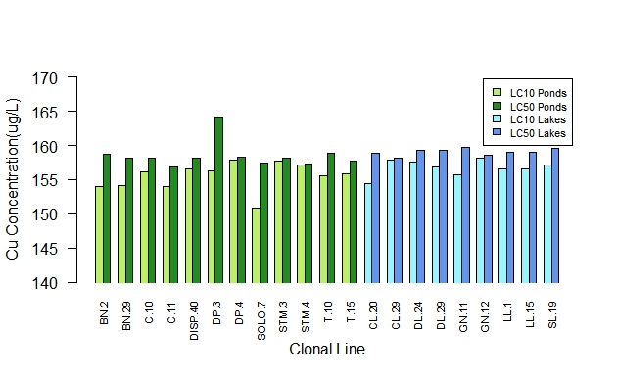

Figure 2: Copper LC₁₀s and LC₅₀s of lines tested in toxicity assays
Effect of diversity treatments on population growth rate and size
Genetic diversity was not found to be predictive of r (p = 0.698), but it was significantly predictive of CV (p = 0.0471). There were also significant differences in r between the paired tanks (p < 0.001) (Table 5 and Figure 3). The post-hoc Tukey test revealed that the low and high diversity treatments were not different from each other in mean CV (p = 0.503) and neither were the low diversity and monoculture treatments (p = 0.184). However, the monoculture treatment did have significantly lower mean CVs from the high diversity treatment (p = 0.041).

Table 5: Results of linear mixed effects models
Nested ANOVA results for CV
Diversity | F _{(2, 6)} = 5.31 | p = 0.0471
Within subgroup | F _{(6, 9)} = 0.336 | p = 0.901
Nested ANOVA results for r
Diversity | F _{(2, 6)} = 0.381 | p = 0.698
Within subgroup | F _{(6, 9)} = 132.11 | p < 0.001

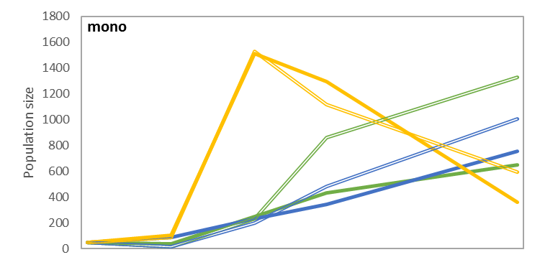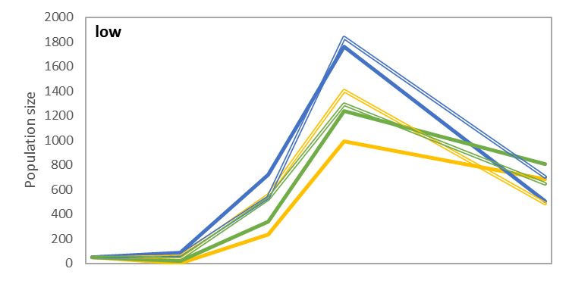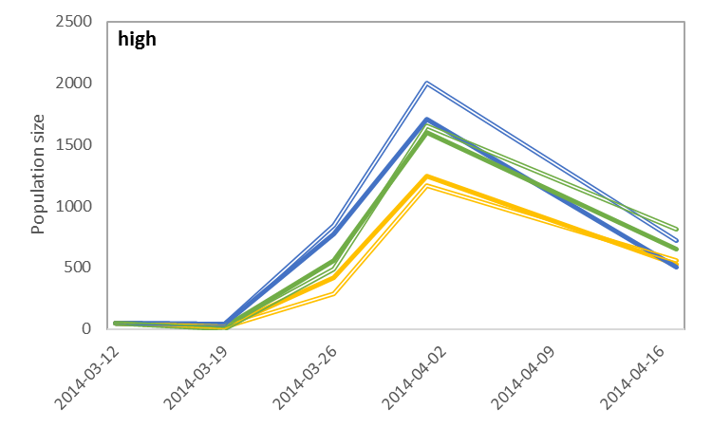

Figure 3: Population size estimates over time for monoculture, low diversity, and high diversity tanks. Matching colours indicate tank pairs within each diversity treatment.

Discussion
The results of the toxicity assay performed in this study suggest that Daphnia pulicaria (the lake variant of the D. pulex species complex) may possibly have a higher tolerance for copper pollution than does the pond variant, D. pulex. This is counter to previous research showing higher copper sensitivity among lake invertebrates . However, this result should be interpreted with caution as the toxicity assay was hampered by very low levels of replication within each clonal line that was assayed. Additionally, the range of copper concentrations evaluated was not perfectly linear owing to a dilution effect during the preparation of the solutions used in the assays. Also, in certain replicate lines, a shift from 0% mortality to 100% mortality was observed after a single step increase in concentration, suggesting that the resolution of the copper concentration gradient used was insufficient. As a consequence of these factors, the standard errors associated with some of the calculated LC values are quite large (Table 3). Therefore, the observed significant differences between the lake and pond variants in LC₅₀ values are quite likely to be attributable to statistical error.
The question of whether copper sensitivity exhibits substantial geographic variability also remains open. While an ANOVA did suggest significant differences in LC₁₀ values exist across habitats, the previously mentioned methodological issues severely impede the interpretation of these results. In particular, the habitats were extraordinarily heteroscedastic (most likely as a consequence of the low level of replication within each habitat) to such a degree that the applied Welch’s correction may not have sufficiently compensated for it. Furthermore, the post-hoc analysis that was performed failed to identify any particularly divergent habitats. It is possible that this is attributable to the conservative nature of the Bonferroni correction . The preferred post-hoc method for data with unequal variances is instead the Games-Howell test . Unfortunately, it could not be applied in this circumstance because the corrected degrees of freedom were too small to generate estimated p-values from the studentized range distribution.
Ultimately, the most robust conclusion that can be drawn from the results of this bioassay are that D. pulex and pulicaria are both sensitive to a very narrow range of copper concentration. Despite the fact that the lines were drawn from a broad geographic range, there is surprisingly little variation in their responses to this stressor. One possible explanation for the lack of significant variation may be the lack of resolution in the concentration gradient used in the assay. However, the narrowness of the range of their responses to copper cannot be explained away. A threshold effect in their sensitivity to copper may be present.
This may have important implications for the ability of these species of Daphnia to adapt to copper stress. In aquatic habitats where Daphnia play a keystone role, high levels of copper pollution may have the potential to substantially upset local food-webs by inducing drastic mortality among the Daphnia population. This conclusion is, however, tempered by concerns about the generalizability of laboratory toxicity assays to natural environments. The bioavailability of metal ions can be significantly tempered by the composition of the medium . Therefore, it would be valuable for future studies to assay D. pulex and pulicaria copper tolerances using natural pond or lake water as a medium.
Meanwhile, the results of the microcosm experiment suggest that the presence of genetic diversity may have an impact on Daphnia population dynamics – specifically on the overall stability of the population. Mean coefficients of variation were lower in the monoculture treatment of the experiment than in the high diversity treatment. The low diversity group was intermediate between the other two. This suggests that increasing levels of diversity may contribute to greater population fluctuations. In contrast, previous research has found the opposite to be true: a phenomena known as the portfolio effect is suggested to stabilize population densities over time with increasing levels of genotypic diversity .
However, there is reason to be skeptical of the results of the present experiment. The significance level of the effect of diversity on CV is quite marginal and the monoculture treatment presents a very limited sample size. It is possible that the differences in dynamics evinced by the monoculture treatment were simply an attribute of the three particular genotypes selected for the treatment. Greater replication, especially at the monoculture treatment level, is required to improve the power of this experimental design to discover genuine effects of intra-specific diversity. Furthermore, there also appears to be significant variation between paired tanks – at least in terms of their intrinsic growth rates (r) – which suggests that the population dynamics in these tanks may be more dependent on other extraneous variables than on genetic diversity.
There were also certain methodological issues that will require further consideration if this manner of experiment is to be replicated. Firstly, the sampling protocol requires improvement. While the protocol was assessed prior to use, the testing method itself had a few flaws. Firstly, it required large numbers of Daphnia to be handled and transferred repeatedly. During this procedure, it is reasonable to expect that some proportion of them would have died. Stress and injuries induced by the transfer procedure may also have hampered the ability of the living Daphnia to escape capture during sampling. The transferred animals were also not given time to acclimate to the new environment before the sampling procedure was tested (doing so would have been time prohibitive and would also have permitted the Daphnia to reproduce, thereby inflating the population size). Therefore, it is quite possible that the behaviour of the Daphnia in response to the sampling procedure was not the same during the testing session as it was in the experiment itself. It is also unknown whether or to what extent the sampling procedure itself induces mortality in the population, which opens the possibility that evasion of the sampling technique could be positively selected for.
Evaporative loss of the medium during the course of the experiment was another major challenge to this experimental method. While it was possible to assess the rate of medium loss over time by weighing the tanks, it remains uncertain how best to convert the tank’s mass into the volume of medium remaining because the biomass contained in the tanks cannot be easily factored out. This issue is of concern because it affects the estimation of the population size – as the volume in the tank drops, the percentage of the tank being sampled increases and therefore a correction must be applied over time to the factor by which the sampled number of Daphnia is multiplied.
A final consideration is the timing of the sampling events. The lack of a significant association between growth rate, r, and genetic diversity could be due to the manner in which r was calculated. The parameter may not have been accurately calculated as the infrequency of sampling means that the true peaks of each tank’s population cycle were probably not captured. A more frequent sampling regime would provide more accurate estimates of these population parameters.
Future work should also investigate how genetic diversity may be eroded over time. The present study assumed that the assigned levels of genetic diversity were accurate (ie. that there was no contamination) and that the levels of diversity remained constant over time. It is unlikely that this is true as it is quite probable that genetic diversity eroded over time . The degree to which this happened merits further inquiry with genetic techniques.
An interesting future direction for this avenue of research is to investigate whether higher levels of genetic diversity could compensate for the effects of metal contamination. Metal exposure has been shown to affect population growth rate, turnover rates, extinction risk, fecundity, competitive interactions, predator-prey interactions, etc. in aquatic invertebrate populations . Meanwhile, a handful of studies have demonstrated an effect of genetic diversity on the ability of aquatic populations to resist disturbances such as these. For instance, clonal diversity in seagrass and eelgrass contributed to resilience against heat waves . In amphipods, population survival following perturbation was improved by increased intra-specific diversity . In a study on Daphnia magna, susceptibility to parasites decreased with increasing genotypic richness . On the other hand, Robinson, Wares et al. (2013) found that genetic diversity in D. magna had no effect on population extinction risk. While the present study was not overly successful at establishing a role of intra-specific diversity in influencing population dynamics, it is possible that more dramatic results could be observed under the influence of a stressor (such as metal pollution), under which conditions genetic diversity might be more likely to play a compensatory role.
Conclusion
The present study puts forward data suggesting that differences in sensitivity to copper may exist between lake (D. pulicaria) and pond (D. pulex) clonal lines. However, we did not find significant variation between clones overall or between different habitat locations in copper sensitivity. The microcosm experiment performed herein found a marginally significant negative impact of genetic diversity on Daphnia population stability, but the direction of the effect runs counter to previous studies examining the portfolio effect. No effect of diversity on population growth rate was observed. However, these conclusions are severely tempered by methodological concerns associated with the levels of replication and resolution of data gathered within the bioassay and microcosm experiment described in the present study. Further research is required to verify these results.

List of Cited References

Altermatt, F. and D. Ebert (2008). "Genetic diversity of Daphnia magna populations enhances resistance to parasites." Ecology Letters 11(9): 918-928.
Barata, C., D. J. Baird and S. J. Markich (1998). "Influence of genetic and environmental factors on the tolerance of Daphnia magna Straus to essential and non-essential metals." Aquatic Toxicology 42(2): 115-137.
Bickham, J. W., S. Sandhu, P. D. N. Hebert, L. Chikhi and R. Athwal (2000). "Effects of chemical contaminants on genetic diversity in natural populations: implications for biomonitoring and ecotoxicology." Mutation Research/Reviews in Mutation Research 463(1): 33-51.
Bolnick, D. I., P. Amarasekare, M. S. Araújo, R. Bürger, J. M. Levine, M. Novak, V. H. W. Rudolf, S. J. Schreiber, M. C. Urban and D. A. Vasseur (2011). "Why intraspecific trait variation matters in community ecology." Trends in Ecology & Evolution 26(4): 183-192.
Bossuyt, B. T. A. and C. R. Janssen (2003). "Acclimation of Daphnia magna to environmentally realistic copper concentrations." Comparative Biochemistry and Physiology Part C: Toxicology & Pharmacology 136(3): 253-264.
Bossuyt, B. T. A. and C. R. Janssen (2005). "Copper toxicity to different field-collected cladoceran species: intra- and inter-species sensitivity." Environmental Pollution 136(1): 145-154.
Brandlova, J., Z. Brandl and C. H. Fernando (1972). "The Cladocera of Ontario with remarks on some species and distribution." Canadian Journal of Zoology 50(11): 1373-1403.
Buser, C. C., J. Fox, A. Kretschmann and P. Spaak (2011). Dirty water and disease: Pesticide mediated interactions between Daphnia and their parasites, University of Zurich.
Cardinale, B. J., J. E. Duffy, A. Gonzalez, D. U. Hooper, C. Perrings, P. Venail, A. Narwani, G. M. Mace, D. Tilman and D. A. Wardle (2012). "Biodiversity loss and its impact on humanity." Nature 486(7401): 59-67.
Celis-Salgado, M. P., A. Cairns, N. Kim and N. D. Yan (2008). "The FLAMES medium: a new, soft-water culture and bioassay medium for Cladocera." Internationale Vereinigung fur Theoretische und Angewandte Limnologie Verhandlungen 30(2): 265-271.
Colbourne, J. K., T. J. Crease, L. J. Weider, P. D. N. Hebert, F. Duferesne and A. Hobæk (1998). "Phylogenetics and evolution of a circumarctic species complex (Cladocera: Daphnia pulex)." Biological Journal of the Linnean Society 65(3): 347-365.
Colbourne, J. K., M. E. Pfrender, D. Gilbert, W. K. Thomas, A. Tucker, T. H. Oakley, S. Tokishita, A. Aerts, G. J. Arnold, M. K. Basu, D. J. Bauer, C. E. Cáceres, L. Carmel, C. Casola, J.-H. Choi, J. C. Detter, Q. Dong, S. Dusheyko, B. D. Eads, T. Fröhlich, K. A. Geiler-Samerotte, D. Gerlach, P. Hatcher, S. Jogdeo, J. Krijgsveld, E. V. Kriventseva, D. Kültz, C. Laforsch, E. Lindquist, J. Lopez, J. R. Manak, J. Muller, J. Pangilinan, R. P. Patwardhan, S. Pitluck, E. J. Pritham, A. Rechtsteiner, M. Rho, I. B. Rogozin, O. Sakarya, A. Salamov, S. Schaack, H. Shapiro, Y. Shiga, C. Skalitzky, Z. Smith, A. Souvorov, W. Sung, Z. Tang, D. Tsuchiya, H. Tu, H. Vos, M. Wang, Y. I. Wolf, H. Yamagata, T. Yamada, Y. Ye, J. R. Shaw, J. Andrews, T. J. Crease, H. Tang, S. M. Lucas, H. M. Robertson, P. Bork, E. V. Koonin, E. M. Zdobnov, I. V. Grigoriev, M. Lynch and J. L. Boore (2011). "The Ecoresponsive Genome of Daphnia pulex." Science 331(6017): 555-561.
Coors, A., J. Vanoverbeke, T. De Bie and L. De Meester (2009). "Land use, genetic diversity and toxicant tolerance in natural populations of Daphnia magna." Aquatic Toxicology 95(1): 71-79.
Costanza, R., R. d'Arge, R. De Groot, S. Farber, M. Grasso, B. Hannon, K. Limburg, S. Naeem, R. V. O'neill and J. Paruelo (1997). "The value of the world's ecosystem services and natural capital." Nature 387(6630): 253-260.
Dodds, W. K., J. S. Perkin and J. E. Gerken (2013). "Human Impact on Freshwater Ecosystem Services: A Global Perspective." Environmental Science & Technology 47(16): 9061-9068.
Dudgeon, D., A. H. Arthington, M. O. Gessner, Z.-I. Kawabata, D. J. Knowler, C. Leveque, R. J. Naiman, A.-H. Prieur-Richard, D. Soto, M. L. J. Stiassny and C. A. Sullivan (2006). "Freshwater biodiversity: importance, threats, status and conservation challenges." Biological Reviews 81(2): 163-182.
Ehlers, A., B. Worm and T. B. H. Reusch (2008). "Importance of genetic diversity in eelgrass Zostera marina for its resilience to global warming." Marine Ecology Progress Series 355: 1-7.
Faria, J. C., E. G. Jelihovschi and I. B. Allaman (2015). Conventional Tukey Test. Ilheus, Brasil, UESC.
Fleeger, J. W., K. R. Carman and R. M. Nisbet (2003). "Indirect effects of contaminants in aquatic ecosystems." Science of The Total Environment 317(1–3): 207-233.
Fox, J. and S. Weisberg (2011). An {R} Companion to Applied Regression, Second Edition. Thousand Oaks CA, Sage.
Games, P. A. and J. F. Howell (1976). "Pairwise Multiple Comparison Procedures with Unequal N’s and/or Variances: A Monte Carlo Study." Journal of Educational and Behavioral Statistics 1(2): 113-125.
Gamfeldt, L. and B. Källström (2007). "Increasing intraspecific diversity increases predictability in population survival in the face of perturbations." Oikos 116(4): 700-705.
Hobaek, A. and L. J. Weider (1999). "A circumpolar study of Arctic biodiversity: Phylogeographic patterns in the Daphnia pulex complex." Ambio 28(3): 245-250.
Hooper, D., F. Chapin III, J. Ewel, A. Hector, P. Inchausti, S. Lavorel, J. Lawton, D. Lodge, M. Loreau and S. Naeem (2005). "Effects of biodiversity on ecosystem functioning: a consensus of current knowledge." Ecological monographs 75(1): 3-35.
Hughes, A. R., B. D. Inouye, M. T. J. Johnson, N. Underwood and M. Vellend (2008). "Ecological consequences of genetic diversity." Ecology Letters 11(6): 609-623.
Hughes, A. R. and J. J. Stachowicz (2004). "Genetic diversity enhances the resistance of a seagrass ecosystem to disturbance." Proceedings of the National Academy of Sciences of the United States of America 101(24): 8998-9002.
Ives, A. R., S. R. Carpenter and B. Dennis (1999). "Community interactions webs and zooplankton responses to planktivory manipulations." Ecology 80(4): 1405-1421.
Koivisto, S. (1995). "Is Daphnia magna an ecologically representative zooplankton species in toxicity tests?" Environmental Pollution 90(2): 263-267.
Koivisto, S. and M. Ketola (1995). "Effects of copper on life-history traits of Daphnia pulex and Bosmina longirostris." Aquatic Toxicology 32(2–3): 255-269.
Koivisto, S., M. Ketola and M. Walls (1992). "Comparison of five cladoceran species in short- and long-term copper exposure." Hydrobiologia 248(2): 125-136.
LeBlanc, G. A. (1985). "Effects of copper on the competitive interactions of two species of cladocera." Environmental Pollution Series A, Ecological and Biological 37(1): 13-25.
Lopes, I., D. J. Baird and R. Ribeiro (2004). "Genetic determination of tolerance to lethal and sublethal copper concentrations in field populations of Daphnia longispina." Archives of Environmental Contamination and Toxicology 46(1): 43-51.
Marshall, J. S. (1978). "Population Dynamics of Daphnia galeata mendotae as Modified by Chronic Cadmium Stress." Journal of the Fisheries Research Board of Canada 35(4): 461-469.
Miner, B. E., L. De Meester, M. E. Pfrender, W. Lampert and N. G. Hairston, Jr. (2012). "Linking genes to communities and ecosystems: Daphnia as an ecogenomic model." Proceedings of the Royal Society B-Biological Sciences 279(1735): 1873-1882.
Perneger, T. V. (1998). "What’s wrong with Bonferroni adjustments." BMJ : British Medical Journal 316(7139): 1236-1238.
R Core Team (2015). R: A language and environment for statistical computing. Vienna, Austria, R Foundation for Statistical Computing.
Reusch, T. B. H., A. Ehlers, A. Hämmerli and B. Worm (2005). "Ecosystem recovery after climatic extremes enhanced by genotypic diversity." Proceedings of the National Academy of Sciences of the United States of America 102(8): 2826-2831.
Robinson, J. D., J. P. Wares and J. M. Drake (2013). "Extinction hazards in experimental Daphnia magna populations: effects of genotype diversity and environmental variation." Ecology and Evolution 3(2): 233-243.
Schindler, D. E., R. Hilborn, B. Chasco, C. P. Boatright, T. P. Quinn, L. A. Rogers and M. S. Webster (2010). "Population diversity and the portfolio effect in an exploited species." Nature 465(7298): 609-612.
Tack, A. J. M., M. T. J. Johnson and T. Roslin (2012). "Sizing up community genetics: it's a matter of scale." Oikos 121(4): 481-488.
van Straalen, N. M. and M. Timmermans (2002). "Genetic variation in toxicant-stressed populations: An evaluation of the "genetic erosion" hypothesis." Human and Ecological Risk Assessment 8(5): 983-1002.
Venables, W. N. and B. D. Ripley (2002). Modern Applied Statistics with S. Fourth Edition. New York, Springer.
Winner, R. W. and M. P. Farrell (1976). "Acute and Chronic Toxicity of Copper to Four Species of Daphnia." Journal of the Fisheries Research Board of Canada 33(8): 1685-1691.
Wogram, J. and M. Liess (2001). "Rank Ordering of Macroinvertebrate Species Sensitivityto Toxic Compounds by Comparison with That of Daphnia magna." Bulletin of Environmental Contamination and Toxicology 67(3): 0360-0367.

